ASSIGNAMENT
WEEK 3 – DAY1 – BUILDING APPS USING LLM1 – AI EXTENSION
Note: - Please check 04 for home assignment. Lokesh S

01 – AI Extension Logo update
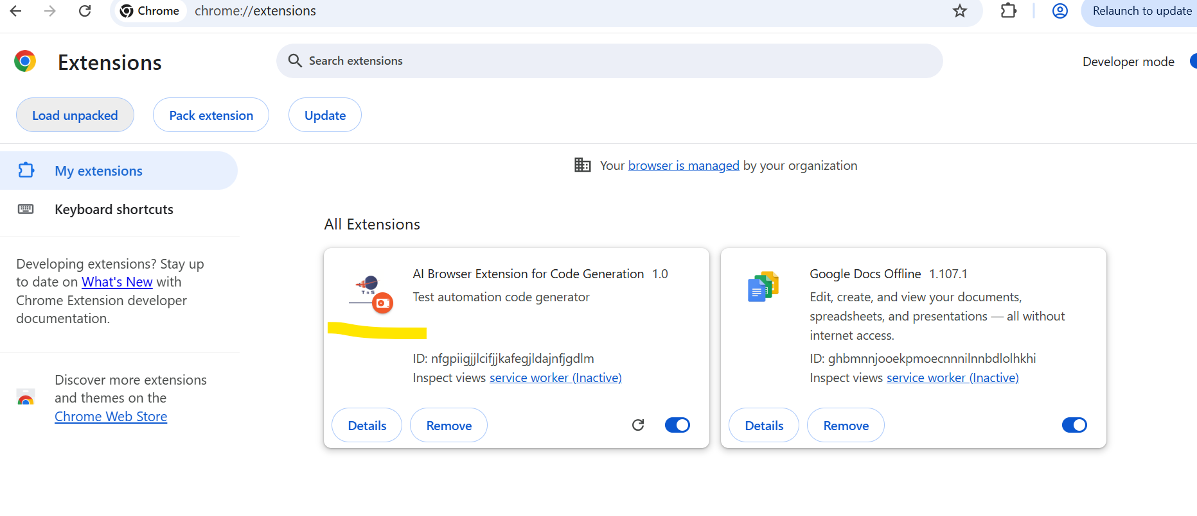
02 – AI Extension Model update
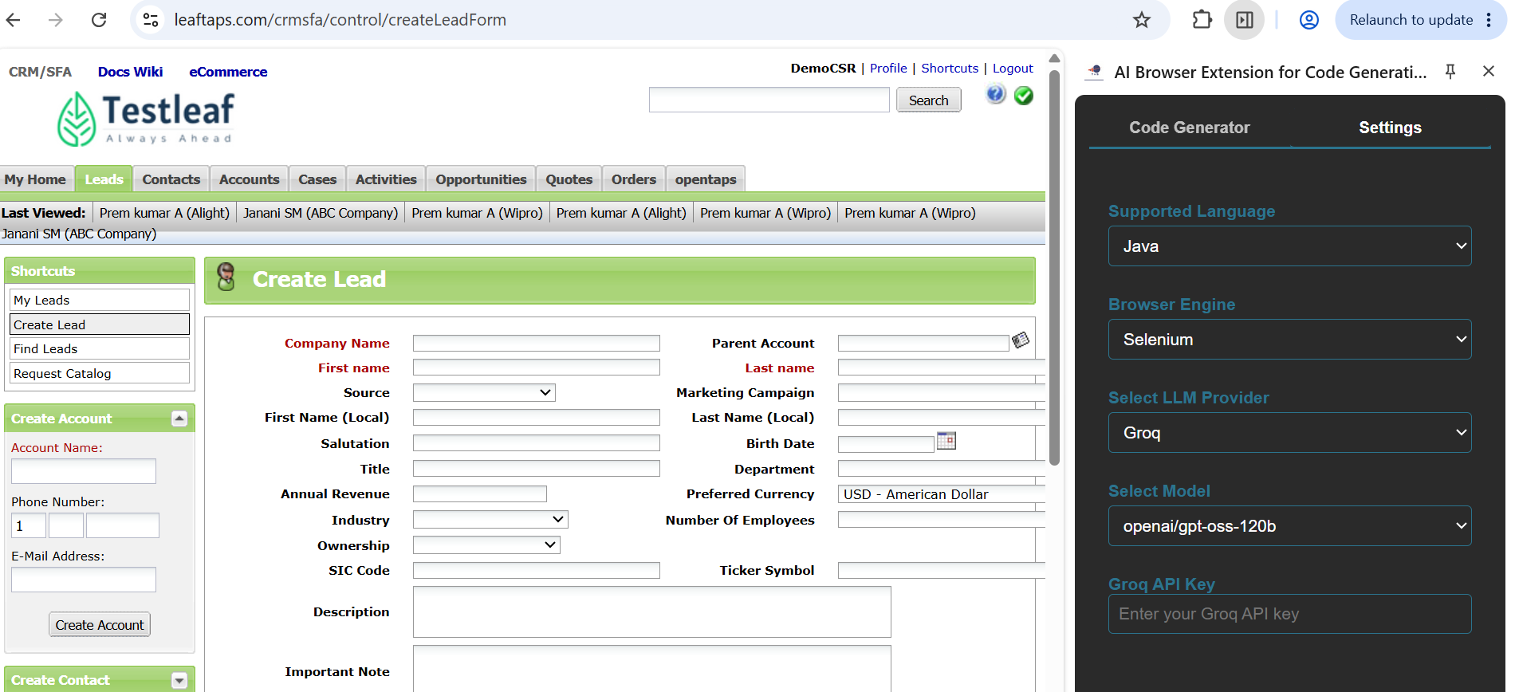
03 – AI Extension code generation and DOM file
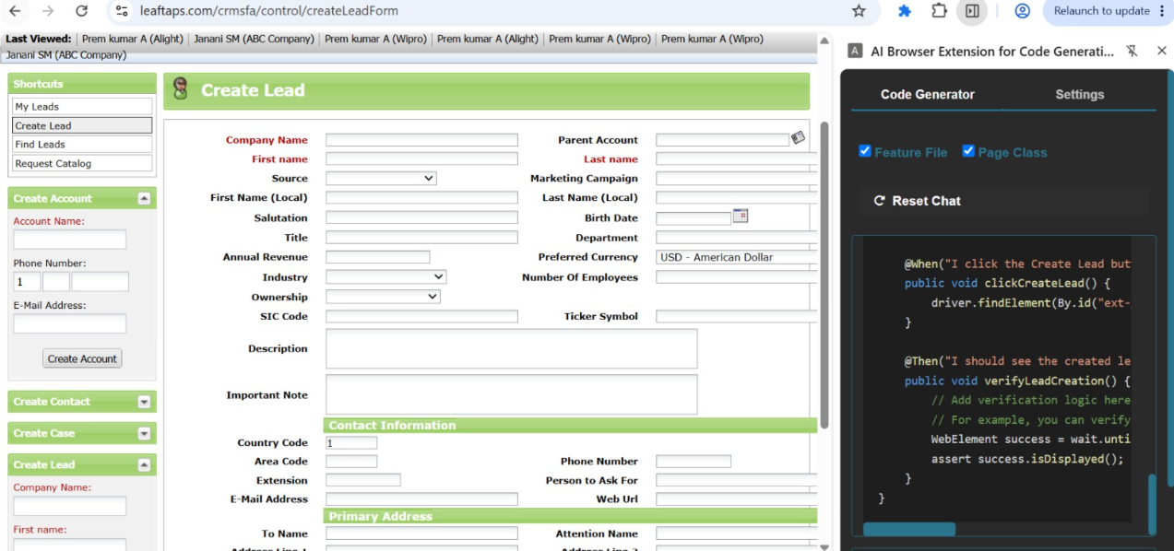
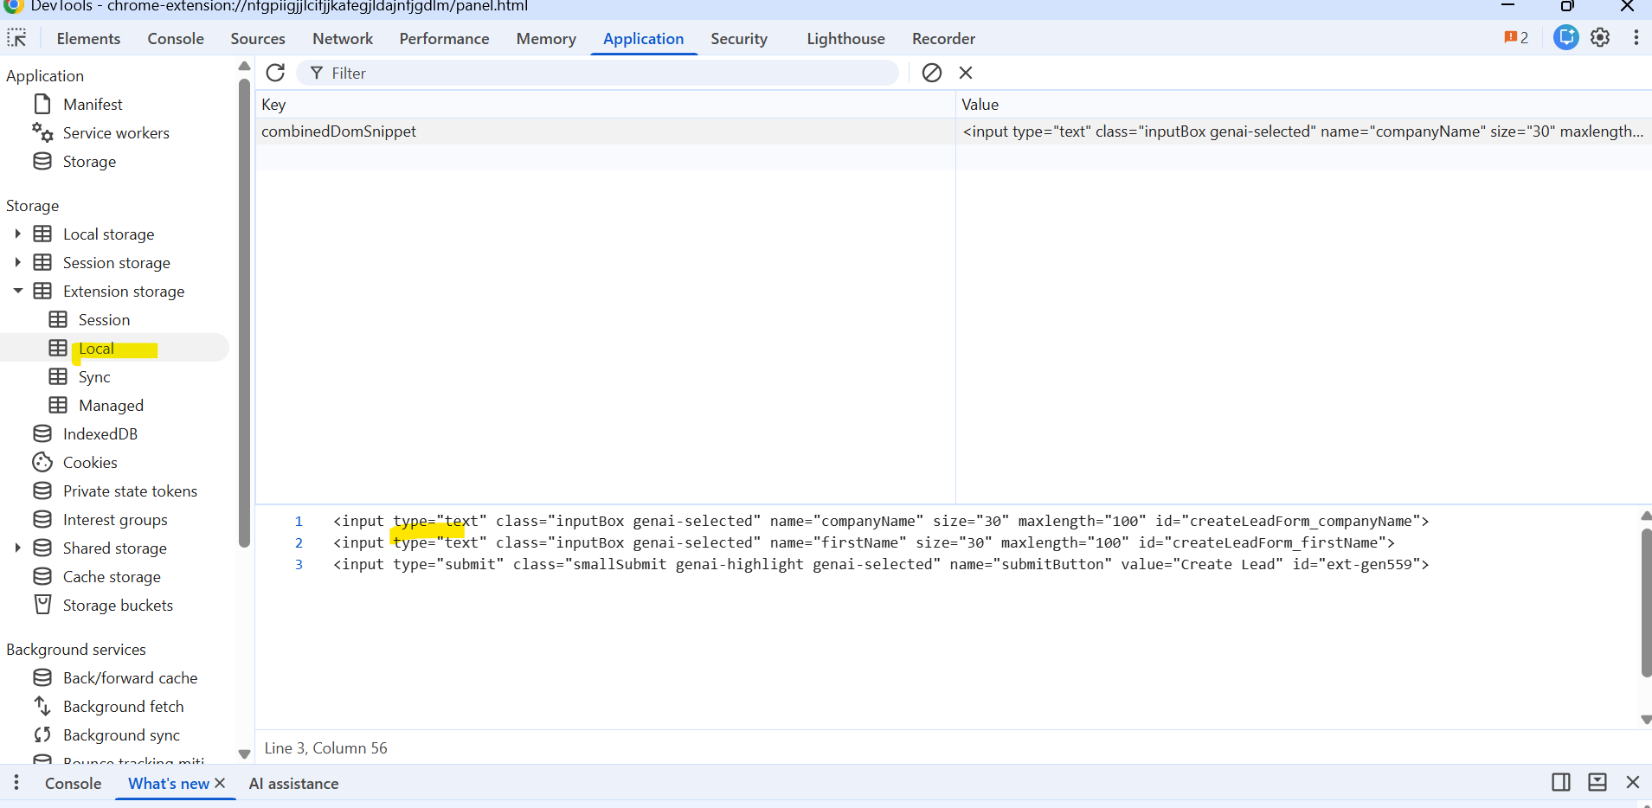

04. With vibe coding implement the playwright/typescript or any other tool which you work say Selenium/Python.

Playwright with Python – Extension
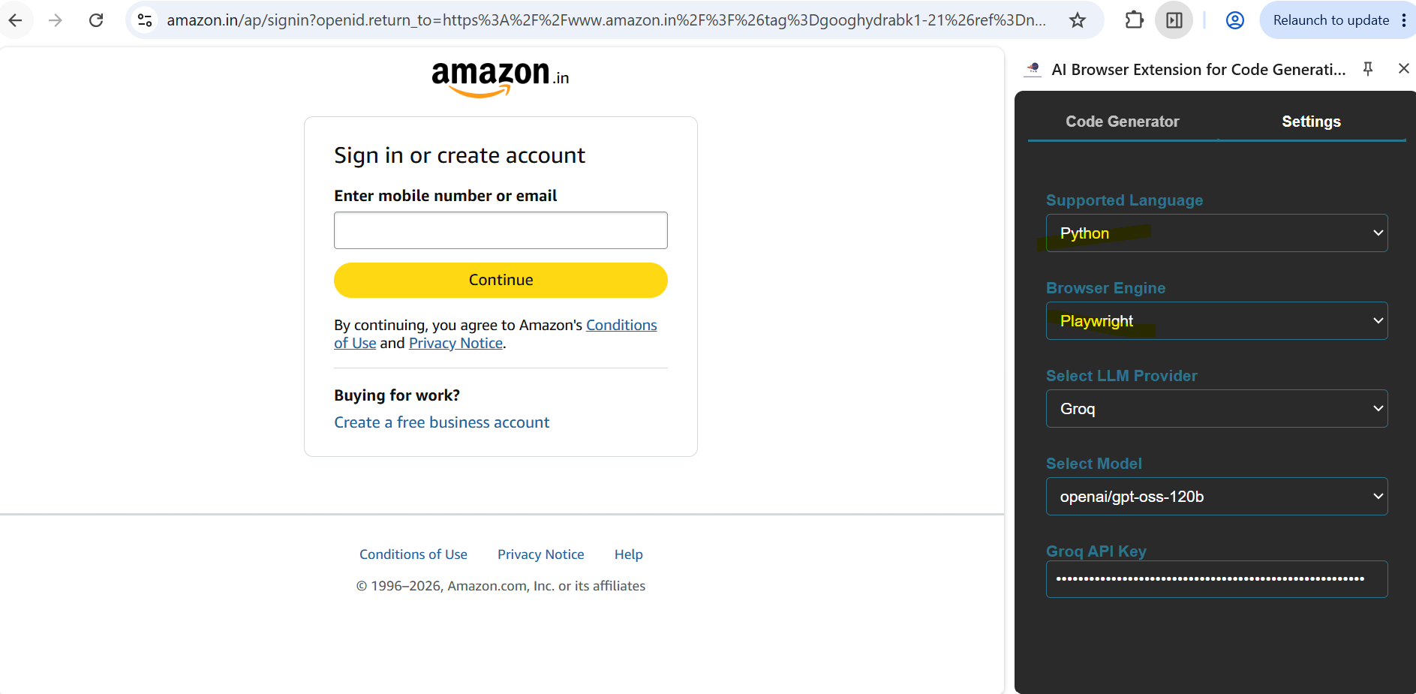

Code Generator
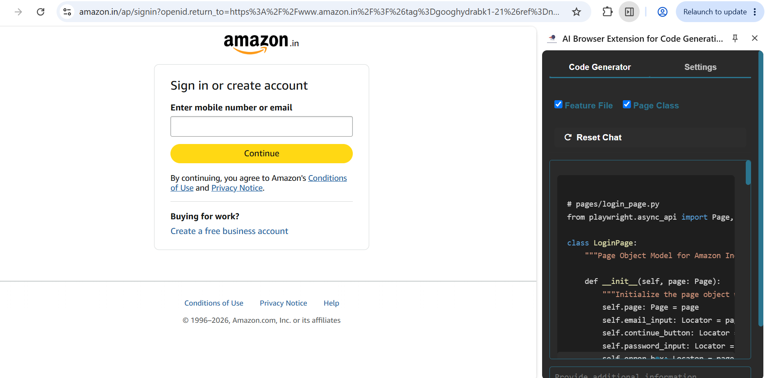

VS Code
